Alaska Child Nutrition Programs is pleased to announce that we now have a listserv. The purpose of the listserv is to provide information and updates on the USDA Child Nutrition Programs, including the National School Lunch Program, the Child and Adult Care Food Program, and the Summer Food Service Program.
To receive all of the hottest news and updates from Alaska Child Nutrition Programs, please sign-up for the listserv here:
http://list.state.ak.us/

The listserv is titled AK_Child_Nutrition_Programs. You will need to find it on the list of Alaska listservs (it’s number 16), and click the ‘join or leave’ link to become a member of our listserv.
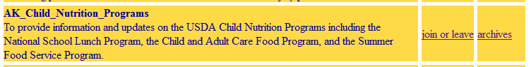
Click here to join

Once you’ve requested to join the Alaska Child Nutrition Programs listserv, a confirmation e-mail will be sent to your e-mail address from Child Nutrition. You have 48 hours to reply to this e-mail in order to finalize your request to join the listserv. If you do not respond to the e-mail within 48 hours, you will have to request to join the listserv again.

