**Positive Behavioral Interventions & Supports (PBIS)**

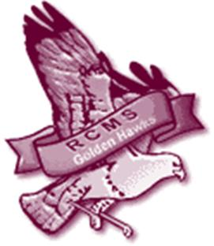

**RCMS Expectations and Rules**

Clemente is all about PRIDE, and we can demonstrate that PRIDE by listening to the Roberto Clemente Golden Hawk.

The Golden Hawk Says to:

* Be Respectful
* Be Responsible
* Be Safe

**Recognition**

* MCj03189020000[1]You will have the opportunity to be recognized for consistently demonstrating positive behavior in all areas of the school.
* You will be recognized by receiving “Clemente Bucks”.
* All staff including teachers, substitute teachers, main office staff, cafeteria staff, custodians, and bus drivers will be awarding “Clemente Bucks”.
* Clemente Bucks can be used at the Clemente’s school store to purchase things like gift certificates, movie passes, and more!
* Your grade level can earn recognition for Peace Days. A Peace Day is a day when no office referrals are given in which the incident disrupts the school community. (Example: Students fighting would be disruptive.)
* Your grade level will be recognized when it reaches 5, 15, 30, 50, 75, and 100 Peace Days. Some rewards are: free seating in the cafeteria, field time, movie and popcorn, dance, and a pizza party.