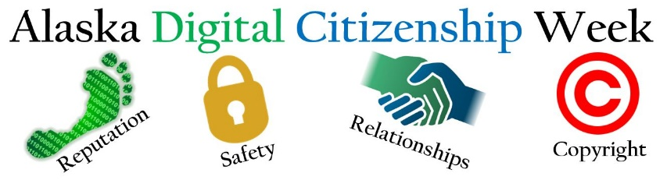

School Leader Implementation Plan

Introduction
Alaska Digital Citizenship Week, is a celebration designed prompt an ongoing effort to teach students how to make safe, smart, and ethical decisions in the digital world. We selected this time on the calendar as all school districts will be in session and it is early enough in the new school year to be a cornerstone in establishing a school culture of digital citizenship.

Before Alaska Digital Citizenship Week
- Add the Alaska Digital Citizenship Week to your district and school calendars and plan to personalize your celebration of Alaska Digital Citizenship Week. Here are some suggestions for making the event your own:
- Alaska Digital Citizenship Week takes a community-based approach. Determine how you will engage parents. You might start with a survey to learn about their daily use and attitudes toward media and technology.
- Support your faculty.
  - Visit Common Sense Education.
    - Take time to become familiar with the curriculum
    - Determine how to recognize faculty that complete the training.
  - See the ‘During’ section for daily themes.
- Go public! Let everyone know you are participating in #AKDigitalCitizenship and #aklearns on Twitter, Facebook and Instagram.

During Alaska Digital Citizenship Week

- Monday: Educate Yourself
  - Share your vision for digital citizenship.​ Get everyone on the same page. If you don’t have a school vision to share at this time, share this video​ with your faculty as a dialogue starter: what is it we want students to​ do with technology?

- Tuesday: Media Balance and Well Being
  - These Media Balance & Well-Being lessons give students the space to reflect on their own media use. Plus, they'll get the tools they need to think critically about how digital media affects our communities and society overall.
    - K-2 Pause for People:
    - 3-5 My Media Choices
    - 6-8 My Media Use: A Personal Challenge
    - 9-12 Social Media and How You Feel
    - Share the Family Tip Sheet with parents:
      - Elementary | Middle & High School

- Wednesday: Privacy and Security
  - Students will learn strategies for managing their online information and keeping it secure from online risks such as identity thieves and phishing. They will learn how to create strong passwords, how to avoid scams and schemes, and how to analyze privacy policies.
    - K-2 That’s Private!
    - 3-5 Pass word Power-Up
    - 6-8 Don't Feed the Phish
    - 9-12 Big Data Dilemma
    - Share the Family Tip Sheet with parents:
      - Elementary | Middle & High School

- Thursday: Digital Footprint and Identity
  - In a time of 24/7 connectivity, do the benefits of online sharing outweigh the risks? Lessons will prompt students to consider how sharing information online can affect them and others and will support them in learning to reflect before they reveal, as well as encourage others to do the same. Students will also learn the pros and cons of having different personae and explore how presenting themselves differently online can affect their sense of self, their reputations, and their relationships.
  - Share the Family Tip Sheet with parents:
      - Elementary | Middle & High School

- Friday: Relationships and Cyberbullying
  - Relationships: As the line between online and offline continues to blur, students reflect on how they can use intrapersonal and interpersonal skills to build and strengthen positive online communication and communities. They will explore common digital stressors and their influences on relationships. Students will also gain an understanding of how to communicate effectively online and how and why some topics and conversations can best lend themselves to certain mediums.
    - Share the Relationships Tip Sheet with parents:
      - Elementary | Middle & High School
  - Cyberbullying: We believe bullying is everybody’s business. Students learn what to do if they are involved in a cyberbullying situation. They will explore the roles people play and how individual actions — both negative and positive — can impact their friends and broader communities. Students are encouraged to take the active role of upstander and build positive, supportive online communities. Learn more and get administrator resources at with the cyberbullying toolkit.
    - Share the Cyberbullying Tip Sheet with parents:
      - All Grades
    - Invite parents and caregivers to learn more about the labels your school uses when talking about bullying situations and strategies. Share the article: Bullying is Everyone’s Business

- Bonus for Weekend: Creative Credit and Copyright.
  - We know that students are not the only ones living in a “copy/paste” culture. We all can benefit from reflecting on our responsibilities and rights as creators in the online spaces where we consume, create, and share information. Share what your faculty is doing to model responsible use. Share the following BrainPop video: Copyright, or see the Alaska Digital Citizenship Week page for more resources.

- Beyond Alaska Digital Citizenship Week
  - Draft a school vision for Digital Citizenship.
  - Put a Digital Citizenship presentation on the agenda for your nearest scheduled school board meeting. (TEMPLATE)
  - Find partners to support ongoing parent/caregiver activities. Resources are available at: Connecting Families. Check out the Program Overview and Program Intro Letter.

