FALL 2023

First Day Certified Vacancy Report
Data Handbook

Due Date: August 31, 2023

Contents
General Information 3
Purpose 3
Regulations 3
First Day Certified Vacancy Dates 4
Changes from the 2022-2023 collection 4
Instructions 4
Record Layout 5
Data Elements 6
Job Codes 8
Teacher Assignment Codes (By Subject Area) 17
Frequently Asked Questions 18
DEED Contacts 19
How to Drop-Off Files Securely Using ZendTo 20

General Information

Purpose
The State Board of Education has requested to know on an annual basis the number of teaching positions that are not filled with an individual possessing a valid Alaska teaching certificate at the start of the school year. This information is necessary to quantify the teacher shortage in Alaska. The information gathered will also inform the annual determination of shortage areas reported annually to the United States Department of Education.

Regulations
4 AAC 18.021 (d)
(a) A person employed to replace a teacher who authorities know will be absent for more than 20 days in which the school is in session must possess a valid Alaska teacher's certificate.
(b) If authorities know that a teacher will be absent for more than 20 in-session days, the district must employ a long-term substitute teacher who holds a certificate issued under 4 AAC 12.305, 4 AAC 12.345, 4 AAC 12.355, or 4 AAC 12.360 under the requirements imposed by this chapter.
(c) If district authorities know that a teacher will be absent for more than 20 in-session days and are unable to employ a qualified applicant who holds a certificate issued under 4 AAC 12.305, 4AAC 12.345, 4 AAC 12.355, or 4 AAC 12.360, the district may employ an individual who holds a retired certificate (Type R) issued under 4 AAC 12.380 and qualified per 4 AAC 12.380(b) as long-term substitute teacher for up to 120 days.
(d) If a substitute teacher who does not possess a valid teacher’s certificate from this state is hired to fill a vacancy at the start of the school year for 20 in-session days or less, a district must notify the department no later than August 31.

4 AAC 12.305 (c) As used in AS 14.20 and this chapter, “teacher” (1) means a person who, for compensation, instructs or teaches students in any grade from preschool – 12th grade, and who is not supervised by another person in the same room, classroom, or other location; (2) includes (A) and administrator who supervises a teacher or an educational program provided by a teacher; (B) a provider of special education or related services who is not regularly supervised by another person in the same room, classroom, or other location; and (3) a school counselor, nurse, or psychologist.

First Day Certified Vacancy Dates

August 15 District contact will be mailed First Day Certified Vacancy Report information. First Day Certified Vacancy data can be submitted to the Alaska Department of Education & Early Development (DEED).

August 31 First Day Certified Vacancy information must be received by DEED. Districts may either send an e-mail for no vacancies to report or submitting the file through ZendTo to eed.edqual@alaska.gov.

Changes from the 2022-2023 collection

There are no changes from last year’s collection.

Instructions
For the 2023 First Day Certified Vacancy Report, districts have two options as to how to summit their vacancy information to the department.

Option 1
For no vacancies email eed.edqual@alaska.gov.

Option 2
Submit the data elements as defined in the record layout using the template provided by DEED. The template can be found at https://education.alaska.gov/forms by querying “First Day.”

Record Layout

NOTE: Include all of the following fields in this order whether relevant or not.

Field Number | Field Name | Field Type | Field Length | Required/Conditional/Optional
1 | DistrictID | Number | 2 | Required
2 | SchoolID | Number | 6 | Required
3 | JobCode | Number | 2 | Required
4 | Assignment | Number | 3 | Required
5 | Assignment2 | Number | 3 | Required
6 | Assignment3 | Number | 3 | Required
7 | Assignment4 | Number | 3 | Required
8 | Assignment5 | Number | 3 | Required
9 | FTE | Number | 3 | Required
10 | ReasonVacant | Number | 1 | Required
11 | RVOther | Text | 100 | Conditional
12 | LengthVacant | Number | 1 | Required
12 | LengthRecruit | Number | 1 | Required
13 | PositionRspsblty | Number | 1 | Required
14 | PROther | Text | 100 | Conditional
15 | OtherInfo | Text | 100 | Conditional

Data Elements
Status | Field # | Description
Required | 1 | District Number  Unique district state ID number
Required | 2 | School Number  Unique school code as assigned by DEED.  A comprehensive list of active school numbers is posted on DEEDS website (https://education.alaska.gov/alaskan_schools/public/DistrictandSchoolIDs.pdf).
Required | 3 | Job Code  Appropriate job code from the list of Job Codes starting on page 8.  If a position has more than one job responsibility, list each job code and the corresponding FTE as a unique record.  Notes:  - All personnel who teach academic subjects must be coded with a teacher job code and corresponding FTE.  - For the teacher job codes, you must include at least one, but not more than five teacher assignment code.
Required | 4 - 8 | Assignment Code  See Assignment Codes on page 17. For teacher job codes only, list at least one assignment code but not more than five assignment codes.  For purposes of this data collection, teacher job codes include:  (13) Remedial Specialist,  (14) Head Teacher,  (15) Teacher,  (16) Visiting or Itinerant Teacher,  (21) Special Education Teacher,  (31) English as a Second Language Teacher,  (40) On-site Supervising Teacher,  (41) Correspondence Teacher,  (74) Online Course Facilitator Teacher, and  (75) Associate Teacher.  If a field is not needed, fill field with NA.
Required | 9 | Full-Time Equivalent (FTE)  This is the FTE for each job code. An FTE of 100 is a full-time position and an FTE of 50 is a half-time position.
Required | 10 | ReasonVacant  1 = Budgetary uncertainty  2 = Actively recruited; no qualified applicants  3 = Employee failed to report; broke contract  4 = Employee released from contract by school board; now recruiting  5 = Certified employee let their certificate lapse  6 = A new position was added  7 = Other (Indicate reason in field #11)
 | 11 | RVOther  If field #10 is equal to 7 (other), a short explanation as to why this position is vacant is required.
 | 12 | LengthVacant  1 = Thirteen days or less  2 = Two weeks to up to four weeks  3 = One month to up to three months  4 = Three months to up to six months  5 = Six to twelve months  6 = More than a year
 | 12 | LengthRecruit  1 = Thirteen days or less  2 = Two weeks to up to four weeks  3 = One month to up to three months  4 = Three months to up to six months  5 = Six to twelve months  6 = More than a year
 | 13 | PositionRspsblty  1 = Substitute (Not Certified)  2 = Certified Substitute; recruitment ongoing  3 = Substitute (Certification pending; will hire when certification is finalized)  4 = Responsibilities are being shared by other employees  5 = Contracting with third party to cover responsibilities  6 = Other (Indicate how position responsibility is being managed in field #14)
 | 14 | PROther  If field #13 is equal to 6 (other), a short explanation as to how the positions responsibilities are being managed during the vacancy is required.
 | 15 | OtherInfo  This field can be used to provide additional information concerning this vacancy.

Job Codes

Code | Job | Description
1 | Superintendent | Directs and coordinates activities concerned with administration of the school system in accordance with Board of Education standards. Also includes Chief administrators of REAAs.
2 | Assistant Superintendent | Assists a superintendent in district-wide administrative duties; Acts as chief administrator of district in superintendent’s absence.
3 | Principal | Directs and coordinates educational, administrative, and counseling activities of primary or secondary school; Chief administrator of a school.
4 | Assistant Principal | Assists principal in school-wide administrative duties; Acts as chief administrator in principal’s absence.
5 | Director/Coordinator | General term for any person who is the lead administrator of a program; Use for directors who are not described elsewhere in the job list.
6 | Coordinator | General term for any person who facilitates activities between at least two groups, such as administrators and instructors, or community and school; Use this code for coordinators who are not described elsewhere in job list.
7 | Consultant | Plans and coordinates educational policies for specific subject area or grade level; Develops programs for in-service education of teaching personnel. Confers with federal, state, and local school officials to develop curricula, and establish guidelines for educational programs.
8 | Director, Personnel | Supervises and/or coordinates activities of compiling and maintaining personnel records.
9 | Director, Maintenance/Facilities | Supervises and/or coordinates activities in keeping buildings and grounds in clean and orderly condition and in maintaining and repairing utility systems and physical structures of building.
10 | Curriculum Specialist | Develops program curriculum and directs teaching personnel of school system in curriculum presentation. Confers with teaching and administrative staff to plan and develop curriculum to meet needs of students. YOU MUST INCLUDE A TEACHER ASSIGNMENT CODE IN CONJUNCTION WITH THIS JOB DESCRIPTION CODE.
11 | Counselor | Counsels students and may provide group educational and vocational guidance services; Assists students to understand and overcome social and emotional problems; Assists in educational and vocational planning.
12 | Librarian/Media Specialist | Administers library and performs related library services; includes selecting, acquiring, classifying, circulating, and maintaining library materials; also furnishing reference bibliographical, and reader’s advisory services.
13 | Remedial Specialist | A certified teacher who acts as a resource consultant to classroom teachers in meeting the needs of students who are remedial in any educational area; May instruct students directly in the area of special needs apart from the general classroom. Do not report non-certified aides here.  YOU MUST INCLUDE A TEACHER ASSIGNMENT CODE IN CONJUNCTION WITH THIS JOB DESCRIPTION CODE.
14 | Head Teacher | Performs duties described under job class of teacher in addition to duties described under job class of principal, head administrator or educational director in a small or rural school where full-time administrative position is not supported.  Use the teacher assignment code of 200 to denote the FTE spent performing administrative duties. You must include a teacher assignment code in conjunction with this job description code.
15 | Teacher | Use for general education teachers only. Use Job Code 21 for Special Education teachers and Job Code 31 for ESL (English as a Second Language) teachers. This job description instructs students in activities designed to promote intellectual, social, and physical growth. Prepares outline for course of study, assigns, and corrects assignments and tests; Records learning process; Maintains order in classroom; Discusses students’ progress with parents; May sponsor extracurricular activities. Use this general job description to cover all subjects and grade levels.  YOU MUST INCLUDE A TEACHER ASSIGNMENT CODE IN CONJUNCTION WITH THIS JOB DESCRIPTION CODE.
16 | Visiting or Itinerant Teacher | An instructor who works directly with students, but travels between different schools within a district.  YOU MUST INCLUDE A TEACHER ASSIGNMENT CODE IN CONJUNCTION WITH THIS JOB DESCRIPTION CODE.
17 | Director Federal Programs | Develops, implements, and administers special and transitional programs; Prepares project applications, budgets, and reports; Directs program activities, orders materials, trains staff in program goals; Works with advisory committees and principals in program development and monitors program through on-site visits. Example programs include: Title I, Title II, etc.  You must include the federal funded FTE for each federal program or consolidated admin, if appropriate.
18 | Manager | A general term for any person who is responsible for directing and coordinating the activities of a program, usually having budget development responsibilities; May be responsible for the hiring and firing, performance evaluations, etc. of his/her employees. Use for managers who are not are described elsewhere in this job list.
19 | Finance Manager | Administers financial business affairs of school district, including payroll, deposits, investments, etc; Keeps financial records and prepares annual financial report. This person would not have budget responsibilities and may report to a business manager.
20 | Nurse | Certified registered nurse: Plan policies, standards, and objectives of school health program, in cooperation with medical authority and administrative school personnel. Participates in medical examinations, and reviews findings to evaluate health status of pupils and progress of program; Cooperates with school personnel in identifying and meeting social, emotional, and physical needs of school children. Administers immunizations and maintains health records of students.
21 | Special Education Teacher | Use for teachers employed as special education teachers. Teacher who provides instruction directly to special education students or who provides consultation services to teachers of special education students. Special education teachers providing instruction in core academic areas, even to alternate achievement standards must indicate the appropriate content/staff assignment code. Consultation may include adapting curricula, using behavioral supports and interventions, or selecting appropriate accommodations. Special educators providing consultation could also assist students with study skills or organizational skills and reinforce instruction that the child has already received in that core academic subject. For special education teachers providing only consultative services, use assignment code 59.  YOU MUST INCLUDE A TEACHER ASSIGNMENT CODE IN CONJUNCTION WITH THIS JOB DESCRIPTION CODE.
22 | Special Assistant to Superintendent | Responsible for the assessment and evaluation of all programs, including student testing, in a large school district; Develops survey procedures, forms etc. to conduct assessment studies for any area or program of the school district. Evaluates survey data, writes reports, and makes recommendations of action to pursue based upon the evaluation.
23 | Supervisor | A general term for any person who is responsible for directing the work, hiring, firing, writing performance evaluations, etc. of other employees; May also have responsibility for budget development, program coordination, etc. Use for supervisors who are not described elsewhere in this job list.
24 | Psychologist | Investigates processes of learning and teaching and develops psychological principles and techniques applicable to educational problems to foster intellectual, social, and emotional development of students.
25 | Psychometrist | Administers, scores, and interprets intelligence, aptitude, achievement, and other psychological tests.
26 | Speech Therapist | Specializes in the diagnosis and treatment of speech and language problems and engages in scientific study of human communication.
27 | Physical Therapist | Plans and administers medically prescribed physical therapy treatment programs for patients to restore function, relieve pain and prevent disability following disease, injury, or loss of body part.
28 | Occupational Therapist | Plans, organizes, and conducts occupational therapy program to facilitate rehabilitation of mentally, physically or emotionally handicapped students.
29 | Audiologist | Specializing in diagnostic evaluation of hearing, prevention, rehabilitation and rehabilitative services of auditory problems, and research related to hearing and attendant disorders.
30 | Recreational Therapist | Assesses students, develop, and carry out therapeutic interventions consistent with students’ needs and interests to maintain the physical, mental, and emotional well-being of the student. Additionally, therapists observe and document student’s participation, reactions, and progress.
31 | English as a Second Language Teacher | Use for teachers employed as ESL teachers. Teacher who provides content instruction to students who are identified as limited English proficient (LEP) students or who provides support or instruction in acquiring the English language. ESL teachers teaching core academic content must provide the appropriate content assignment code. For ESL teachers providing only English language support or instruction, use assignment code 15 (ESL).  YOU MUST INCLUDE A TEACHER ASSIGNMENT CODE IN CONJUNCTION WITH THIS JOB DESCRIPTION CODE.
32 | Bilingual/Bicultural Coordinator | Supervises bilingual/bicultural center staff. Supervises use of program funds; Provides direction for principal in developing bilingual/bicultural programs. Express goals of program to parents of students and coordinates parent and community involvement in program. Assists in workshops for staff development and coordinates the introduction of culturally relevant materials into the general curriculum.
33 | Orientation and Mobility Specialist | Provides services to blind or visually impaired students to enable them to attain systematic orientation to and safe movement within their environments in school, home and community. These services include teaching students the following as appropriate: spatial and environmental concepts, use of the long cane, to understand and use remaining vision and distance low vision aides, and other concepts, techniques, and tools.
34 | Correspondence Program Coordinator | Selects correspondence curriculum materials to meet the educational needs of remote students; Develops curriculum materials, visits students as needed to assist in completing course, corrects and evaluates progress, supervises other correspondence instructors and is responsible for the reporting requirements of the program.
36 | Student Affairs Coordinator | Plans and arranges social, cultural, and recreational activities of various students’ groups.
37 | Director of Community Education | Promotes volunteerism and involves community experts in offering a wide variety of programs and classes. Coordinates between districts and other community agencies and organizes and maintains community involvement procedures. Develops annual plan of service for grant application, oversees Community Education program budget.
38 | Director of Special Education | Formulates special education programs and policies for school or district relating to education and training of mentally and physically handicapped students.
40 | On-site Supervising Teacher (not to be used for correspondence teachers) | Use for teachers whose primary responsibility involves supervision of a class of students receiving a distance delivered instruction or computer-based instruction (such as PLATO). Use Job Code 21 for Special Education teachers and Job Code 31 for ESL (English as a Second Language) teachers. Use job code 41 for Correspondence teachers. And a general job description to cover all subjects and grade levels.  YOU MUST INCLUDE A TEACHER ASSIGNMENT CODE IN CONJUNCTION WITH THIS JOB DESCRIPTION CODE.
41 | Correspondence Teacher | Use for teachers who work with distance delivery students. Responsibilities include selecting materials to meet the educational needs of students, monitoring learning progress, and evaluating progress to make determination of grades.  YOU MUST INCLUDE A TEACHER ASSIGNMENT CODE IN CONJUNCTION WITH THIS JOB DESCRIPTION CODE.
42 | Director of Education, Elementary or Secondary | Plans, develops, and administers programs to provide educational opportunities for students. Develops and analyzes curriculum.
45 | Child Study Coordinator | Coordinates placement of students in special education programs, administers programs and evaluates students’ needs; Conducts conference with instructors, parents, and students to develop individualized study plans; Coordinates placement in proper program for students entering school or moving to another school.
46 | Computer Operator/Programmer | Analyzes business procedures and problems to refine data and convert it to a programmable form for electronic data processing; Prepares programs for computer to process business, or other data, according to operating instructions.
47 | Public Information Coordinator | Plans and conducts public relations programs designed to disseminate facts and information about district’s activities or programs to the general public; May coordinate exchange of information between remote sites within the district.
50 | Administrative Assistant | Working under the supervision of a Manager, Director, or Superintendent, oversees all aspects of general office coordination.
51 | Business Manager | Administers business affairs of school district; Prepares operating budget, keeps financial records, and prepares annual financial report.
53 | Other Professional | Use for any professional employee whose duties are not described elsewhere in the job list.  Please include a description of job in the Notes field.
70 | Staff Developer/Mentor Teacher/Instructional Coach | Evaluates teaching techniques and recommends changes for improvements; Conducts workshops and conferences for teachers to study new classroom procedures, new instructional materials, and other aids to teaching; Assists in recruitment and in-service training of teachers. Works with teachers to improve classroom-teaching skills but does not directly teach in classroom.
71 | Director of Career & Technical Education | Oversees the development, updating and renovating of courses which provide students with instruction in vocational areas and skills; Coordinates advisory committee and community involvement in program, oversees purchase of materials, works with principals and vocational education instructors in meeting program goals, acts as liaison with counseling and special service workers to provide services to career & technical program students with special needs, prepares state and federal reports, program budget, etc.
72 | Director of Curriculum | Develops program curriculum and directs teaching personnel of school system in curriculum presentation. Confers with teaching and administrative staff to plan and develop curriculum to meet needs of students.
73 | Social Worker | Assist students with academic learning by providing strategic services that identify and address the social-emotional-environmental issues that interfere with the educational process. Works with parents/guardians, teachers, school principal/principal’s designee, and community-based resources to implements strategies that promote students’ positive school adjustment.
74 | Online Course Facilitator Teacher | Use for teachers whose primary responsibility involves facilitation of an approved online course for students. Responsibilities include facilitating course access, monitoring learning progress and serving as the teacher of record including confirmation of grades. Use Job Code 21 for Special Education teachers and Job Code 31 for ESL (English as a Second Language) teachers. Use Job Code 41 for Correspondence teachers. General job description to cover all subjects and grade levels.  YOU MUST INCLUDE A TEACHER ASSIGNMENT CODE IN CONJUNCTION WITH THIS JOB DESCRIPTION CODE.
75 | Associate Teacher | Performs the duties described under the job class of teacher as a bilingual instructor or as an Alaska Native cultural or language instructor. A certified teacher, administrator or university professor is providing oversight and supervision of curriculum outside of the culture and language areas that the associate teacher provides instruction.

Teacher Assignment Codes (By Subject Area)

Code | Description | GL
 | Elementary Grades
301 | Elementary Math Specialist (K-6) | E
302 | Elementary Language Arts Specialist (K-6) | E
303 | Elementary Science Specialist (K-6) | E
304 | Elementary Social Studies Specialist (K-6) | E
305 | Elementary Reading Specialist (K-6) | E
306 | Elementary Music Specialist (K-6) | E
307 | Elementary Art Specialist (K-6) | E
308 | Elementary Foreign Language Specialist (K-6) | E
99 | Pre-Elementary | E
100 | Kindergarten | E
101 | Grade 1 | E
102 | Grade 2 | E
103 | Grade 3 | E
104 | Grade 4 | E
105 | Grade 5 | E
106 | Grade 6 | B
107 | Grade 7**(only teachers teaching all subjects) | S
108 | Grade 8**(only teachers teaching all subjects) | S
113 | Multi-Grade Elementary (grades preK-6 only) | E
 | Arts/Fine Arts
3 | Art | S
52 | Band | B
176 | Dance | B
8 | Theater | S
34 | Music | S
 | Language Arts
14 | English | S
63 | Language Arts | S
195 | Literature | S
41 | Reading | S
47 | Speech | S
45 | Writing | B
 | Mathematics
201 | General Math (Grades 6-8) | S
202 | Pre-algebra | S
203 | Algebra I | S
204 | Algebra II | S
205 | Geometry | S
206 | Pre-calculus | S
207 | Calculus | S
208 | Calculus Advanced Placement | S
209 | Advanced Math other than those listed | S
210 | Basic Math (Grades 9-12) | S
211 | Integrated Math | S
212 | Computer Science Programming | S
 | Science
5 | Biology | S
7 | Chemistry | S
11 | Earth Science | S
20 | General Science | S
22 | Geology | S
23 | Advanced Science | S
28 | Life Science | S
36 | Physical Science | S
38 | Physics | S
 | Social Sciences/Studies
2 | Anthropology | S
193 | Psychology | S
192 | Sociology | S
190 | American History | S
12 | Economics | S
21 | Geography | S
27 | History | S
37 | Political Science/Civics | S
46 | Social Studies | S
191 | World History | S
 | Special Education
57 | Adaptive Physical Education | B
98 | Early Childhood Special Education Teacher | E
59 | Special Education consultative services | B
900 | Special Education – taught to alternate standards | B
 | World Languages
309 | American Sign Language | B
175 | Chinese | B
15 | English as a Second Language (language instruction or support) | B
16 | French | B
18 | German | B
173 | Japanese | B
177 | Latin | B
112 | Alaska Native Language | B
19 | Other World Language | B
174 | Russian | B
17 | Spanish | B
 | Career & Technical Education (CTE)
6 | Business Education: includes office practices, computer applications… | S
30 | Career Exploration | S
26 | Family & Consumer Science: includes home economics, culinary arts, child dev… | S
68 | Health Occupations | S
29 | Industrial & Engineering Technology: includes woods/metals shop | S
9 | Information Technology Services: includes CISCO, A+, Computer repair… | B
24 | Media & Graphic Arts: includes photography, web design, desktop publishing… | S
1 | Natural Resources: includes fisheries, marine science, mining, forestry, agriculture… | S
310 | Student Aide | S
171 | Transportation: includes auto, aviation and small engines. | S
55 | Work Based Learning Coordinator: includes Co-op, on the job training (OJT) | S
 | Other
49 | Alaska History | S
194 | Alaska Native Arts | B
189 | Alaskan Studies | S
4 | Bilingual/Bicultural | B
10 | Driver Education | S
170 | Gifted/Talented (resource only) | B
200 | Head Teacher Admin. Duties | B
25 | Health | B
178 | Intro to Computers | B
32 | Library | B
64 | Outdoor Education | B
35 | Physical Education | B
172 | Remedial Skills | B
160 | ROTC | S
60 | Tutor (resource only) | B
199 | Yearbook | S

Frequently Asked Questions

Who is required to report?
All districts are required to annually report this information to DEED.

For this data collection, what is the definition of a vacancy?
A vacancy is an unoccupied certified position identified by the district for the current school year. The vacancy may be the result of a new position created because of increased enrollment; a position abandoned by a contracted, certified educator; or a position that was advertised but did not attract a candidate that met the district’s requirements or needs. For the purpose of this data collection, a position is also considered vacant if the educator holding a position has an expired Alaska teaching certificate on the first day of school or is in the process of applying for certification with the Alaska Department of Education & Early Development.

If a position is filled, but the educator hired for the position is on leave, does the district need to report this position in this data collection? No.
What is the first day of school?
The first day of school is the first day that a certified educator would be required to report to work. For teachers, it would be the first day that they are contractually obligated to report.

DEED Contacts
Questions relating to the content of this collection should go to:
Sondra Meredith
Education Administrator II
465-8663
sondra.meredith@alaska.gov

Questions relating to the submission of this collection should go to:
Jeanny Smith
Education Associate II
465-2884
jeanny.smith@alaska.gov

How to Drop-Off Files Securely Using ZendTo
A Quick Guide from the Alaska Department of Education & Early Development
- Go to the Alaska ZendTo website (drop.state.ak.us/drop/).
- Click on “Drop-off”.
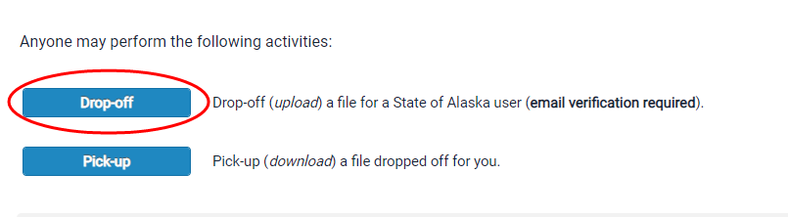
- On the next page, you will be prompted to enter in some information about yourself (the sender). Please enter in your name, your organization, and your email address.
- At the bottom of the screen, you will be asked to confirm that you are a real person by checking the indicated box.
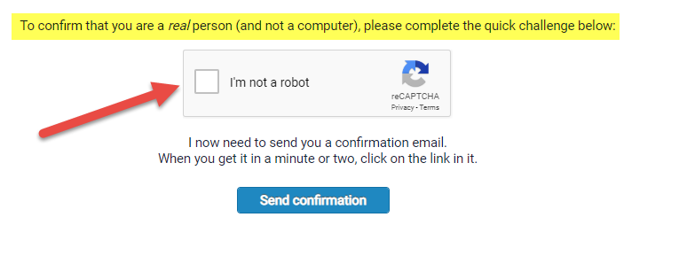
- Then click “Send Confirmation”.
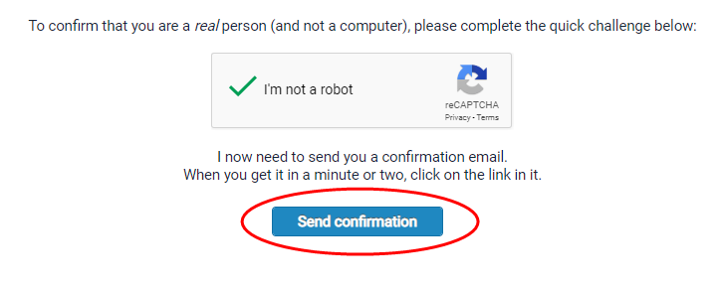
- The next page confirms that an email has been sent to the email you entered from ZendTo. This email should arrive just moments after this screen.
- This is an example of what this email referenced above looks like. Click on link to be re-directed to the ZendTo site.
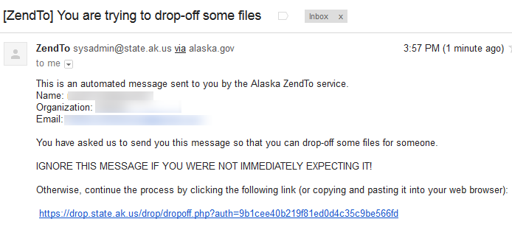
- The link in the email will take you to a page that looks like the screen below. Your name and email will already be in the ‘From’ field. You will need to fill in the ‘To’ field by clicking the green plus sign.
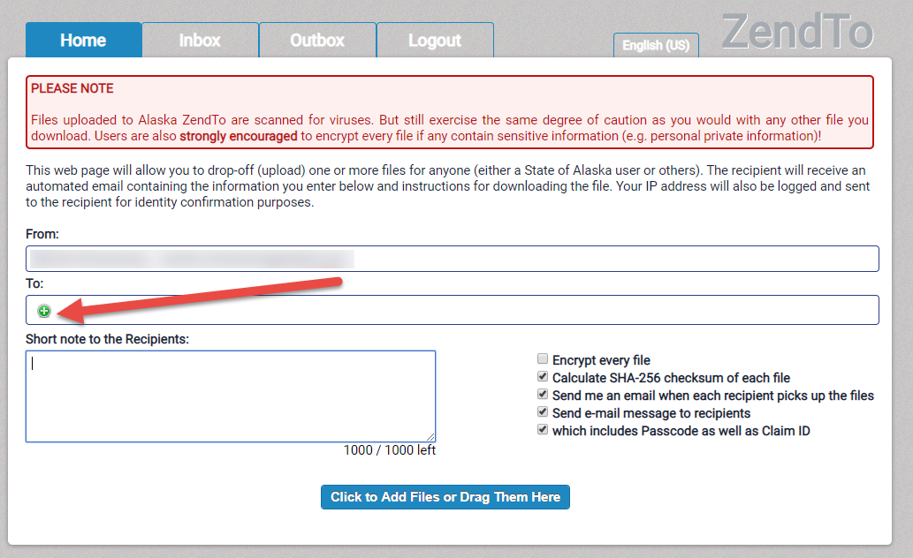
- A window will appear. This is where you enter the name and email of the person you wish to send the files to. Select ‘Add’ to add another recipient. Select ‘Add & Close’ when you are finished entering recipients. Once you select ‘Add’ or ‘Add & Close’, the recipient will appear in the ‘To’ field.
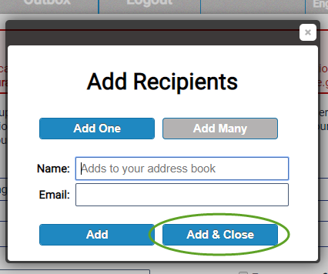
- Attach the file you wish to send by dragging files into the ZendTo window or by selecting ‘Click to Add Files or Drag Them Here’.
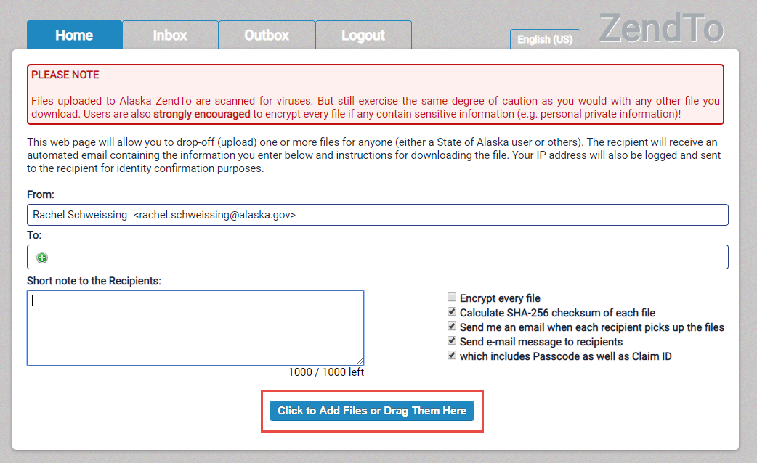
- If you choose to add the file from your computer, select the file you wish to send.
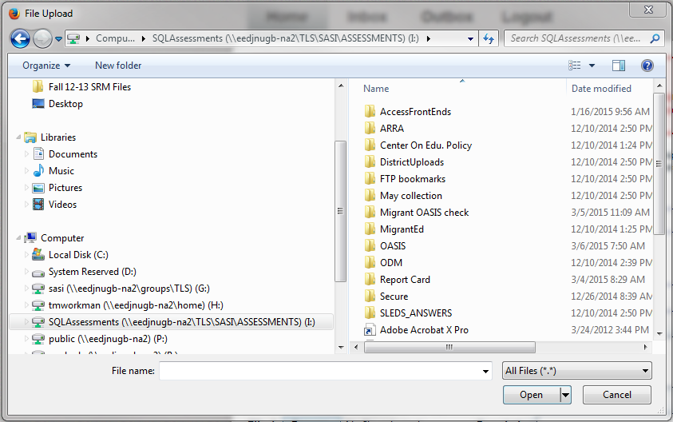
- After you select a file, it will appear under the heading ‘Filename’ and next to the number 1. You may choose to enter a description in the box next to your file. You also may select the red ‘x’ next to the description box to delete your file. Follow steps 10 and 11 for each file you wish to send.
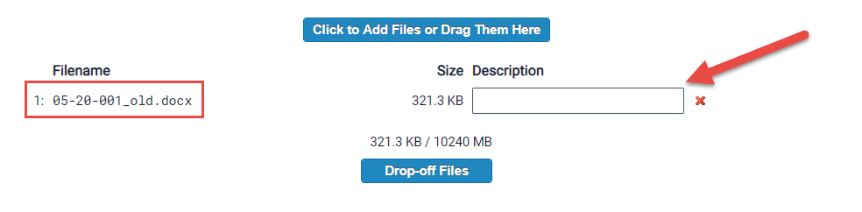
- After you are finished uploading files, you may choose to write a short note to the recipient(s) in the box.
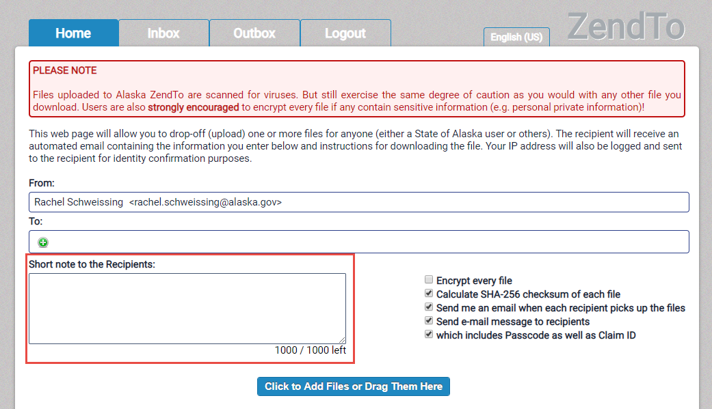
- Remember to select the “Encrypt every file” checkbox before submitting. A window will appear, and you will need to enter an Encryption Passphrase. Then select ‘OK’.
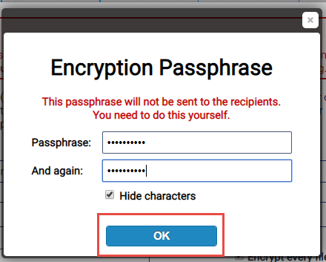
- Once an Encryption Passphrase has been chosen, please email the passphrase to eed.edqual@alaska.gov. Without this passphrase, DEED will not be able to access the files you send.
- Once you have sent DEED your passphrase, select ‘Drop-off Files’.

