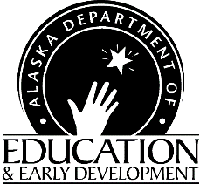

CNP Web

User Deactivation Request

Teaching and Learning Support

Child Nutrition Programs
801 West 10th Street, Suite 200
PO Box 110500
Juneau, Alaska 99811-0500
907- 465-8708
FAX 907-465-8910

Instructions: Fill out this form and e-mail or fax it to Child Nutrition Programs (us). Retain a copy for your files.

Representing Sponsor/Agency Name(s):
Fiscally Responsible Authority Requesting Deactivation:

Contact number for Fiscally Responsible Authority:

Please terminate access for:
Name:
Title:
No longer an employee
Change in job task
Security Compromised
Other:

Fiscally Responsible Authority Signature Date

NOTE: Please update your User Authorization Request forms as often as changes occur to reflect only those currently approved to view or enter data and/or approve claims.

State Official Use Only:

Deactivation request completed by:
Date:

